Task 3: Success based on location selection

Location is determined by latitude and longitude for any business. Success is determined by the ratings given by the customer. So I have used two tables such as reviews and table business to get the information about business.

Sent data from mysql to hive by using sqoop

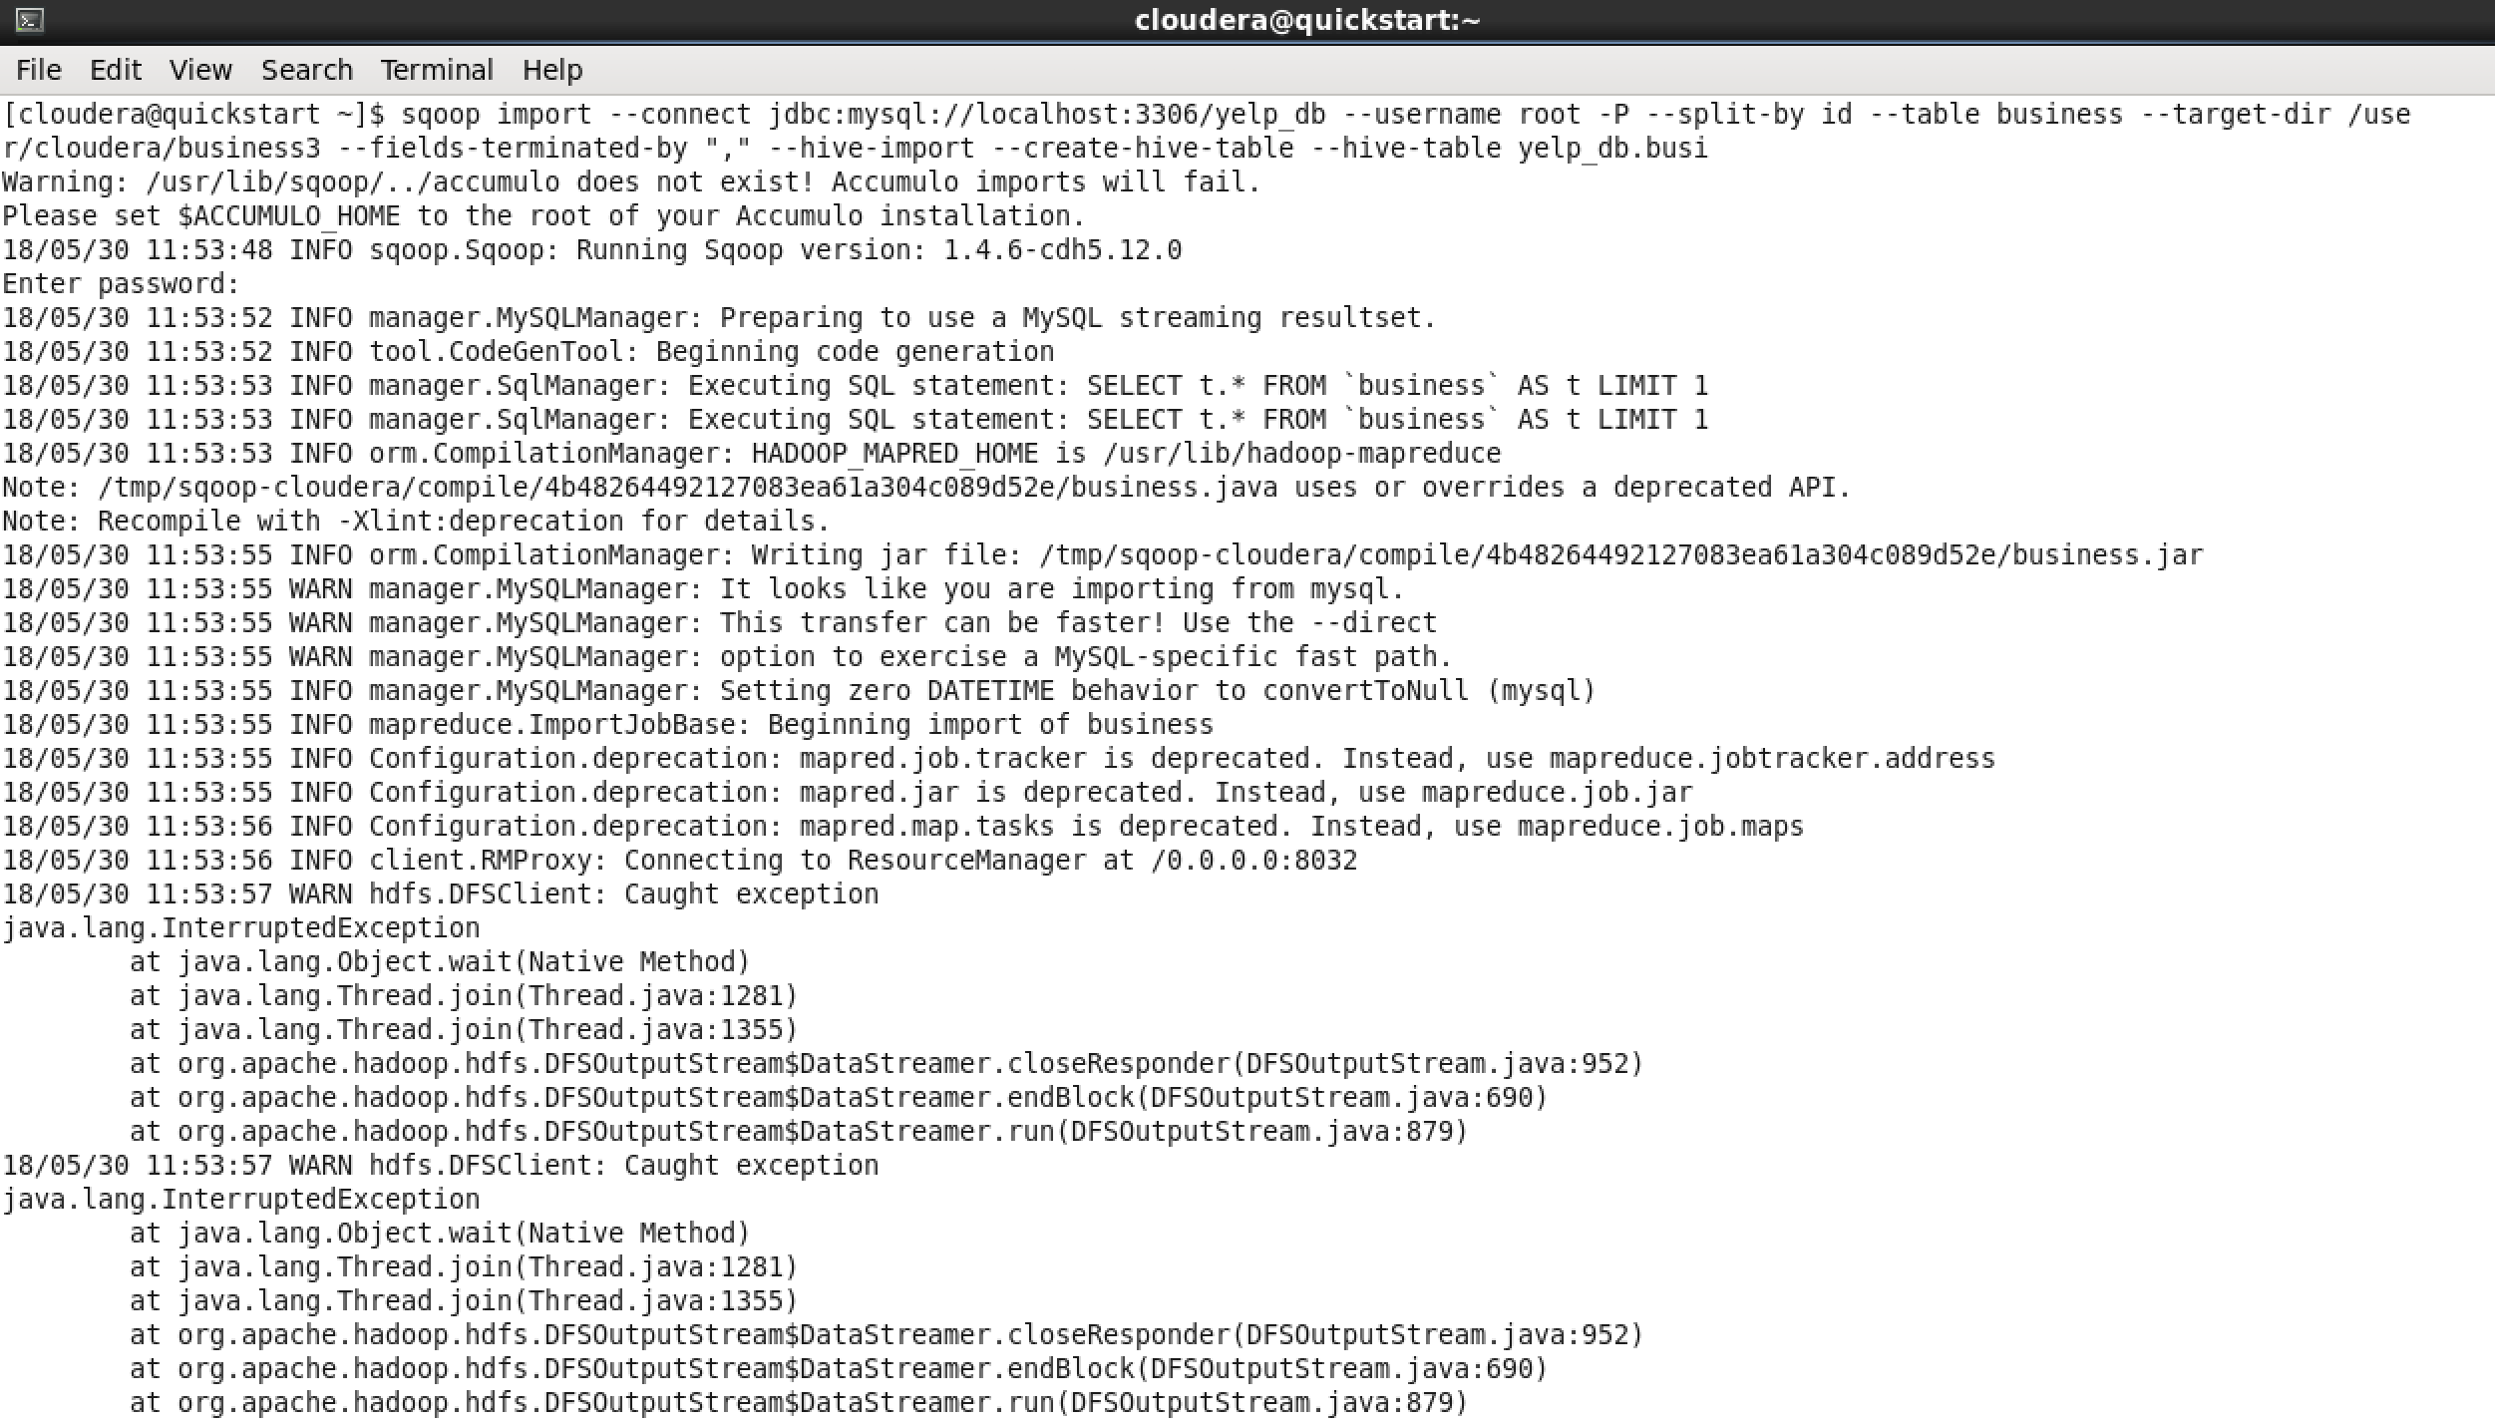

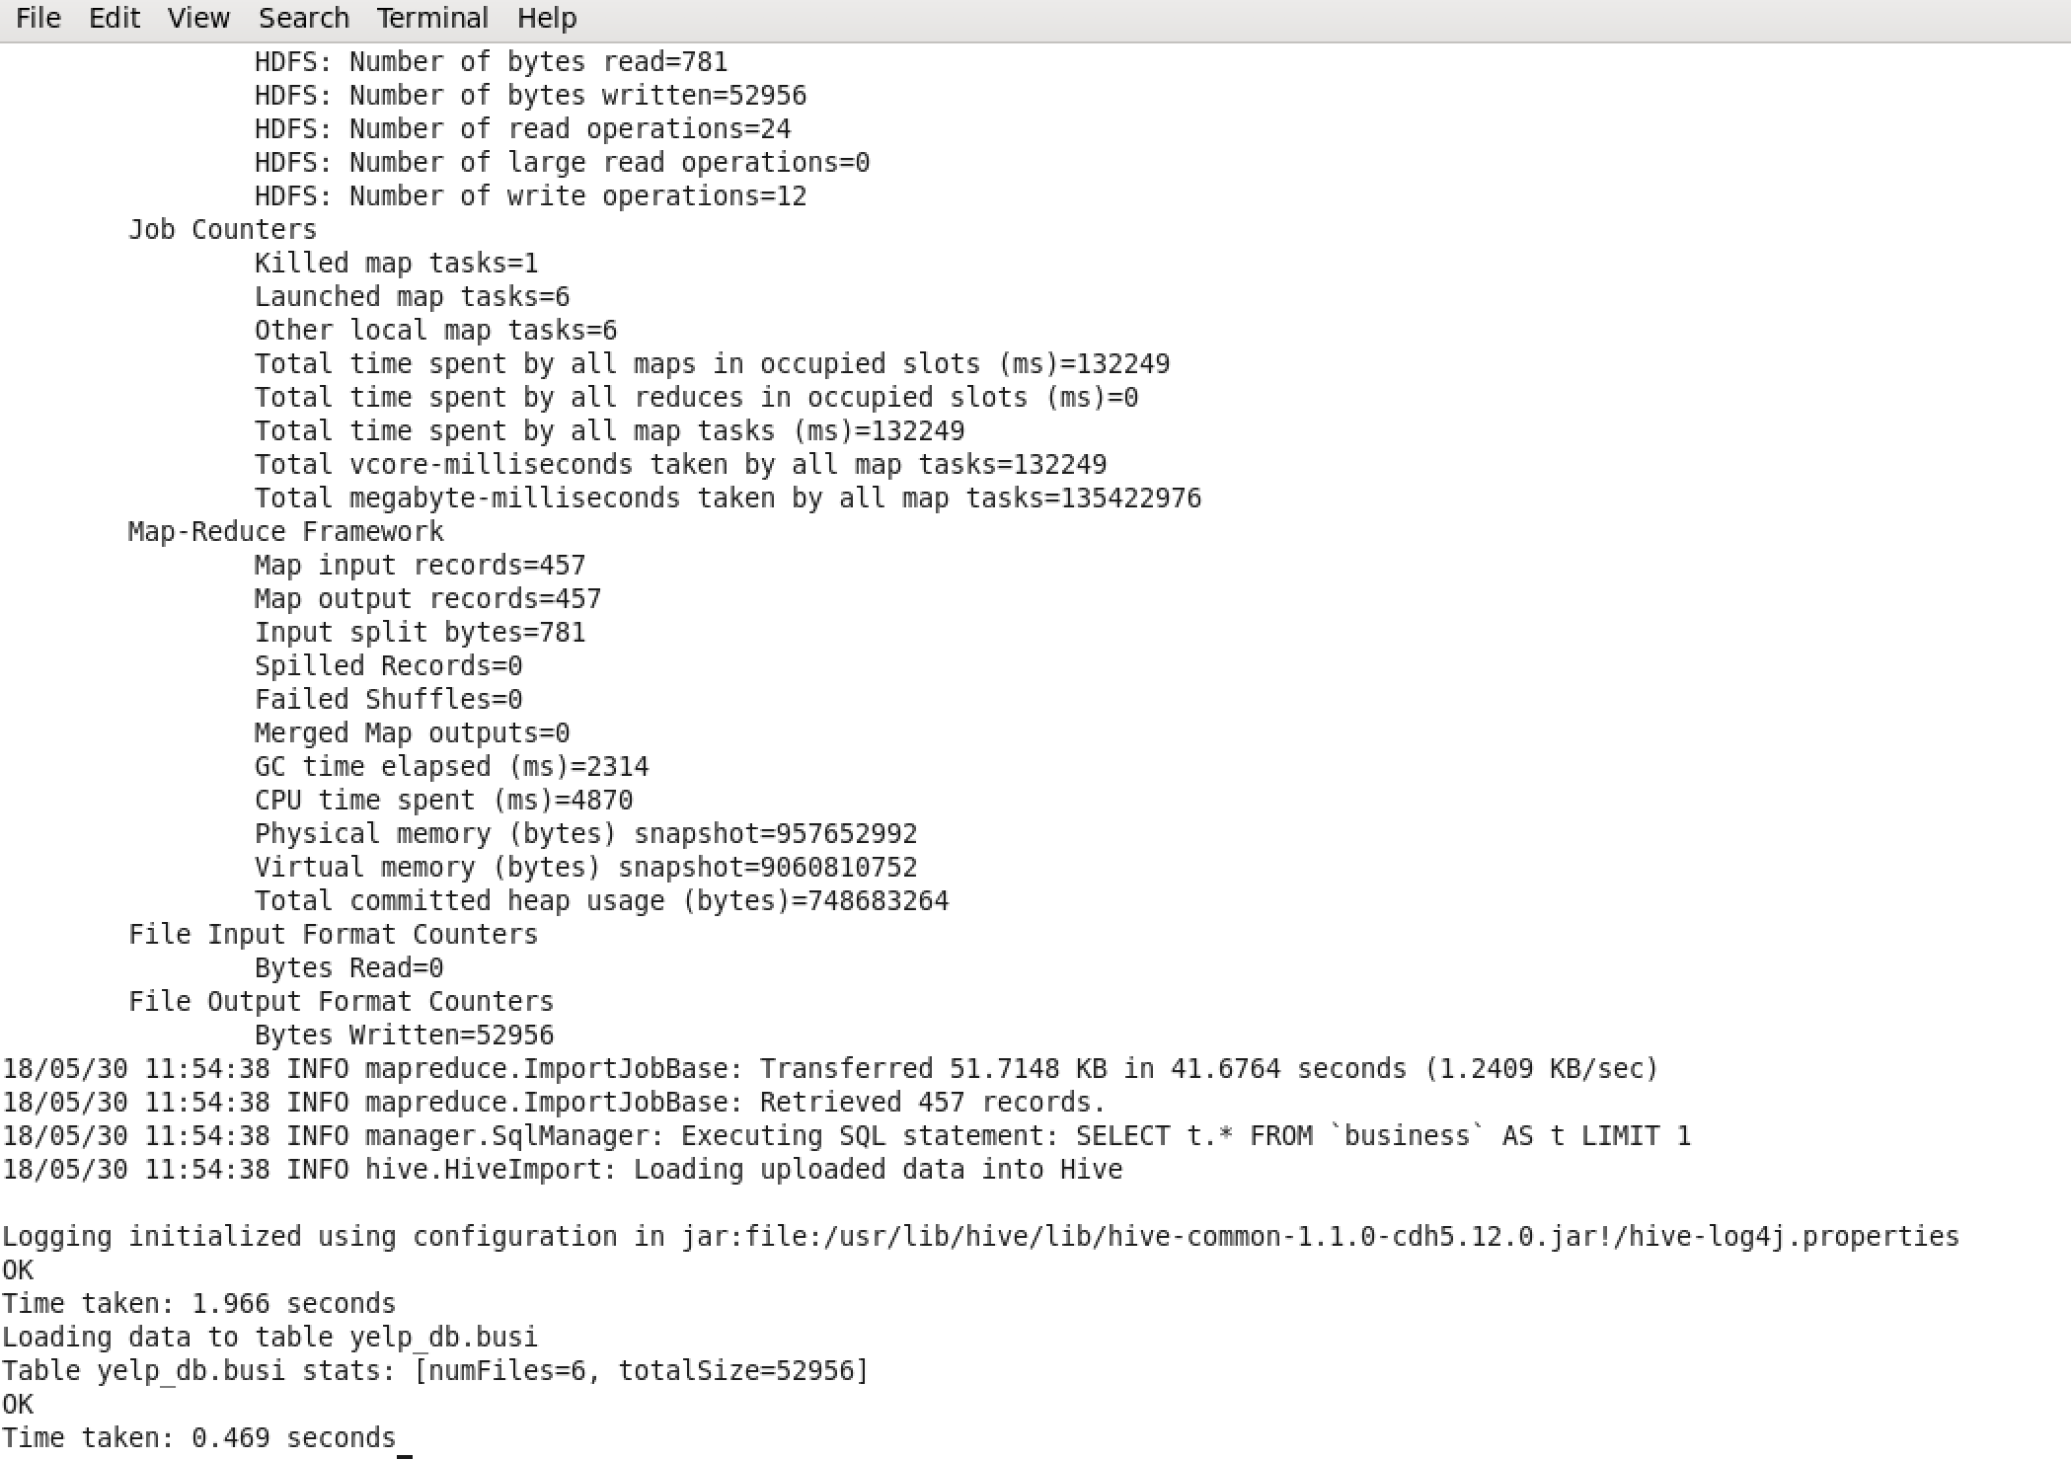

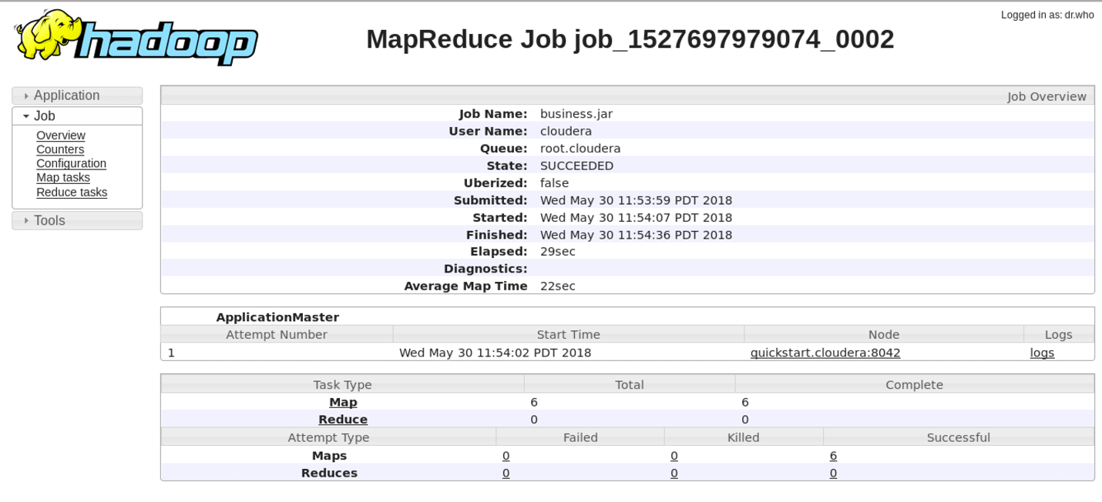

The path of the HDFS location is :



OUTPUT:

Select b.id, b.name, b.longitude, b.latitude, b.stars from business b where stars = 5;

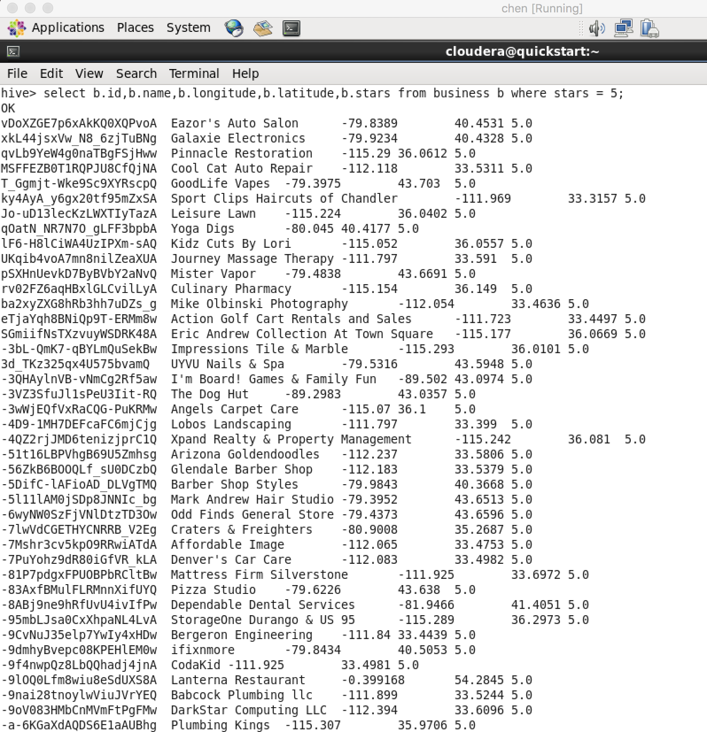

Task 4: Success based on city selection

The success of city is determined by ratings given by the customers. So I have used two tables such as reviews and table business to get the information about business.

Select b.name, b.city, b.state, b.postal_code, b.stars from business b where stars = 5;

OUTPUT:

